# COMPUTER SCIENCE & ENGINEERING



**Experiment: 3.1**

Student Name: Vivek UID:

Branch: CSE Section/Group:

Semester: 3rd Date of Performance:1-11-2022 Subject Name: Database Management System

Subject Code:21-CSH-14

1. **Aim/Overview of the practical:** Introduction and implementation of procedures.
2. **S/W Requirement:** Oracle Database 11g Express Edition or Oracle Live Sql
3. **DBMS script and output:**

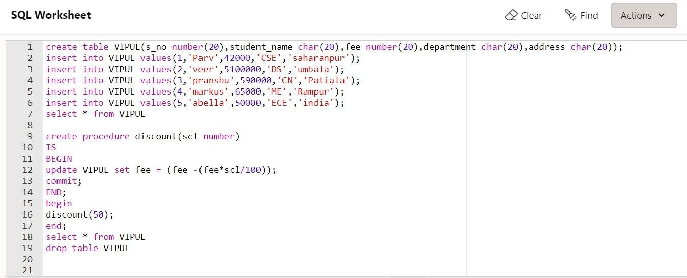

# COMPUTER SCIENCE & ENGINEERING



